**Table of Contents**

|  |  |  |
| --- | --- | --- |
| **SNo.** | **Title** | **Page**  **No.** |
| 1 | Introduction | 5 |
| 2 | Objectives/Scope of the Analysis | 6 |
| 3 | Source of dataset | 7 |
| 4 | ETL Process | 9 |
| 5 | Analysis of dataset | 10 |
| 6 | List of Analysis with results | 11-15 |
| 7 | Final Dashboard | 16 |
| 8 | Bibliography | 17 |

**Introduction**

The global chain of footwear and accessories is owned and operated by a Canadian multinational retailer known simply as ALDO. Aldo Benayoun founded the company in Montreal, Quebec in 1972 and is still headquartered in the city's Saint Laurent district. With nearly 3,000 stores in 100 countries and he has grown into a global company with three retail brands (ALDO, Call It Spring/Spring and GLOBO). The overseas stores are franchised stores, but the group owns stores in Canada, the United States, the United Kingdom and Ireland. Prior to closing or renaming, the company represented the following brands:

Little Burgundy (sold to Genesco), Simard & Voyer, Christian Shoes, Access, Pagabo, Transit, Stoneridge, Locale, Feetfirst and FIRST.

**Objectives and Scope Analysis**

Over the past decade, more and more attention has been paid to sustainability in each raw material sector, especially in the footwear sector. Compounds commonly used in the past to reduce the noise of machinery working in factories, increase energy efficiency, improve working conditions for those involved in the design and manufacture of shoes, etc. It helps to ensure an acceptable level of sustainability in the footwear sector compared to what is achieved in the production situation and overall not only from an environmental protection point of view but also from an improved social condition point of view. had a positive impact on, also economical.

For this project, I'm working from the perspective of a potential competitor who would like to understand each shoes separately. Some of the things we will look to analyze are its product categories, pricing structure, distribution of its offer, how the product is marketed, how the purchase of shoes vary within states, what their customers are asking for, how different measures impact customer satisfaction, and so on.

**Source of Dataset**

https://view.flodesk.com/pages/62e6c1afc4d48aec3664b8e4

**Web URL:**

Flodesk is a digital marketing services provider built by developers for developers. Use it to design and send marketing emails about your brand, create highly converting sales and checkout pages, publish opt-in forms to grow your lists, and build powerful email automations.

**Dataset sample with Data fields given below:**

From the image given below, we can see multiple columns with names such as:

1. Retailer
2. Retailer ID
3. Invoice Date
4. Region
5. State
6. City
7. Product
8. Price per Unit
9. Units Sold
10. Total Sales
11. Operating Profits
12. Operating Margin
13. 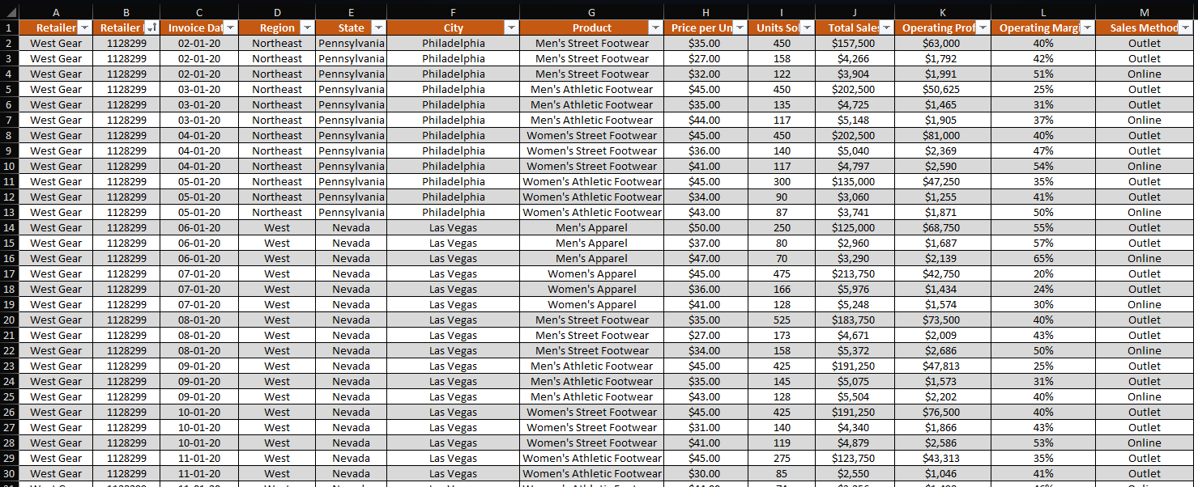Sales Method

**ETL Process**

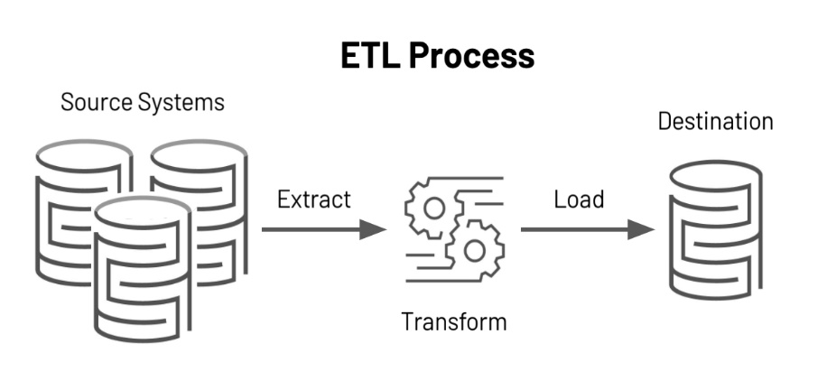ETL is defined as the process of extracting data from various RDBMS source systems, transforming the data (for example, applying calculations, consolidations, etc.), and finally loading the data into a data warehouse system. A complete ETL form is Extract, Transform, and Load. It's easy to think of creating a data warehouse as simply extracting data from multiple sources and loading it into the data warehouse database. This is far from the truth and requires a complex ETL process. The ETL process is technically demanding, requiring active input from various stakeholders such as developers, analysts, testers, and executives.

**Need of ETL Process**

* 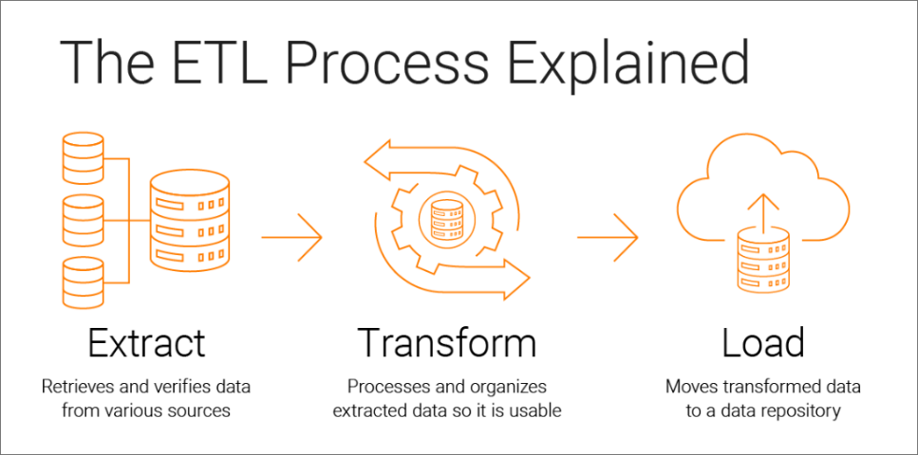ETL process allows sample data comparison between the source and the target system.
* ETL is a predefined process for accessing and manipulating source data into the target database.
* Allow verification of data transformation, aggregation, and calculations rules.

When it comes to the implementation of the ETL process, the itinerary of tasks can be divvied up into the full form of its acronym.

1. **E – Extraction**
2. **T – Transformation**
3. **L – Loading**

**Analysis on Dataset**

1. **Sales /year.**

* By performing this analysis, we would be able to understand sales growth per year.

**Specific Requirements, functions and formulas**:

Sorting with product count in descending order to get highest number in the first position.

**Analysis results**:

Retailer named “Footlocker” has sold more than other retailers i.e., 2637 products.

1. **Sales acquired by each market.**

* Table

  Description automatically generatedBy performing this analysis, we would be able to understand sales growth per year in each market.
* Here, market is of three types:
* In-store market.
* Outlets.
* Online stores.

**Specific Requirements, functions, and formulas**: For comparing total sales among each type of markets, we took sum value and sorted from largest to smallest (descending order).

In order to add the currency symbol, we can get it change the format from number to its accounting format.

Note: If we need the decimal places of money value, we can edit it in decimal places as shown in figure.

**Analysis Result:** In-store markets tend to be the most sales made over the years i.e $356,643,750.

1. **Sales / region.**

* By performing this analysis, we would be able to understand sales growth per state, city or even between countries.
* 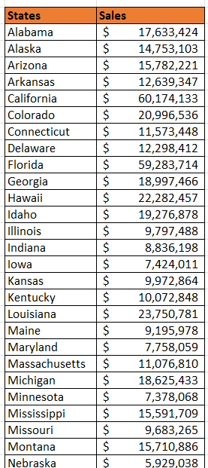With the help of above data, we can plot maps depicting sales across states/ regions.

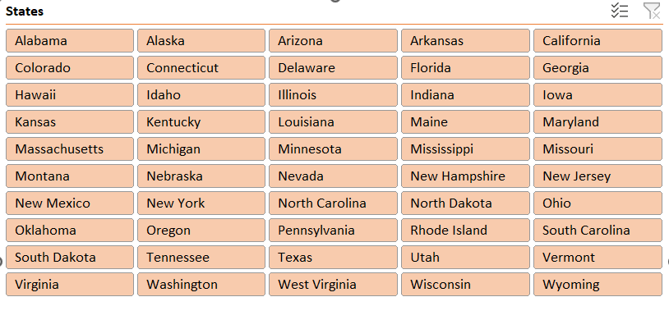**Slicer**

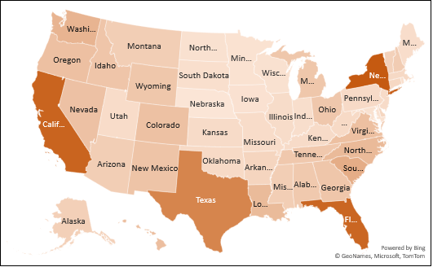**Visualization**

**Slicer**

**Visualization**

**Slicers**

**Visualization**

**Slicers**

**Visualization**

**Final Dashboard**

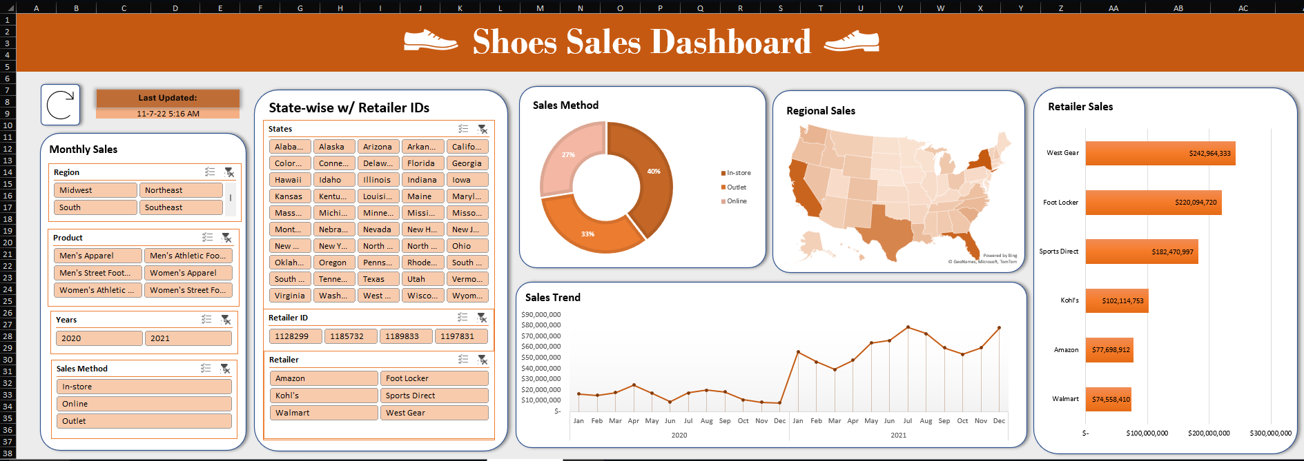

**Bibliography**

* [**https://www.ibm.com/in-en/cloud/learn/etl**](https://www.ibm.com/in-en/cloud/learn/etl)
* [**https://view.flodesk.com/pages/62e6c1afc4d48aec3664b8e4**](https://view.flodesk.com/pages/62e6c1afc4d48aec3664b8e4)
* [**https://www.simplilearn.com/tutorials/excel-tutorial/excel-formulas**](https://www.simplilearn.com/tutorials/excel-tutorial/excel-formulas)